**AWS S3, CloudWatch and CloudTrail - POC**

Step 1: Create Two S3 Buckets

Primary Bucket: This is where your objects will initially be uploaded.

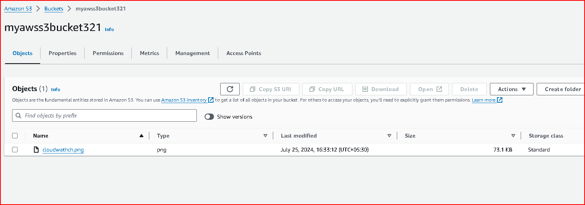

Replica Bucket: Objects from the primary bucket will be replicated to this bucket.

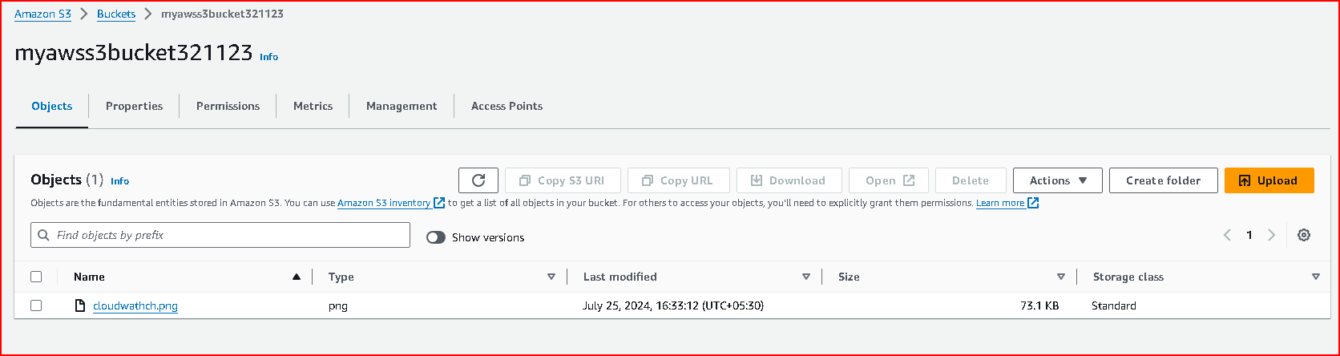

Ensure both buckets are in the same AWS region.

Step 2: Enable Versioning on the Buckets

Versioning must be enabled on both the primary and replica buckets for replication to work properly.

Enable Versioning:

Go to the AWS Management Console.

Navigate to the S3 service.

Select your primary bucket.

Go to the Properties tab.

Click on Versioning and enable versioning.

Repeat these steps for the replica bucket.

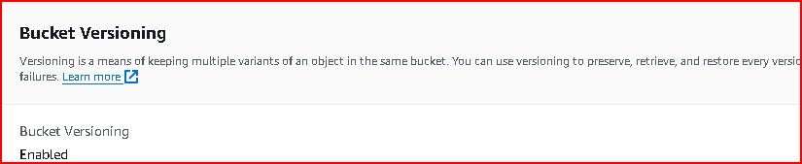

Step 3: Configure Cross-Region Replication (CRR)

Since both buckets are in the same region, you will configure Same-Region Replication (SRR) instead of Cross-Region Replication.

Configure Same-Region Replication:

Select your primary bucket.

Go to the Management tab.

Click on Replication and then + Add rule.

Follow the prompts to configure replication:

Source: Choose the primary bucket.

Destination: Choose the replica bucket.

Choose the replication options as per your needs.

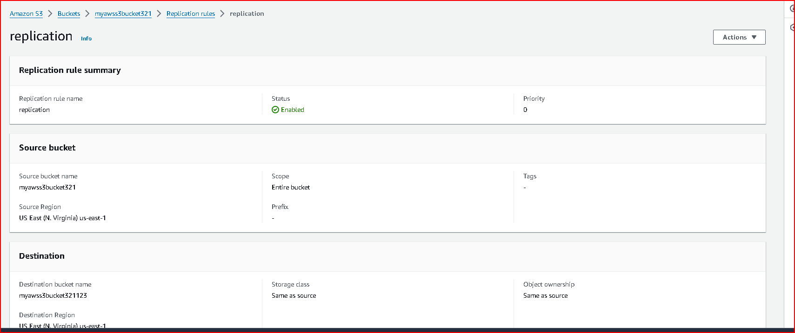

Upload the object in source bucket.

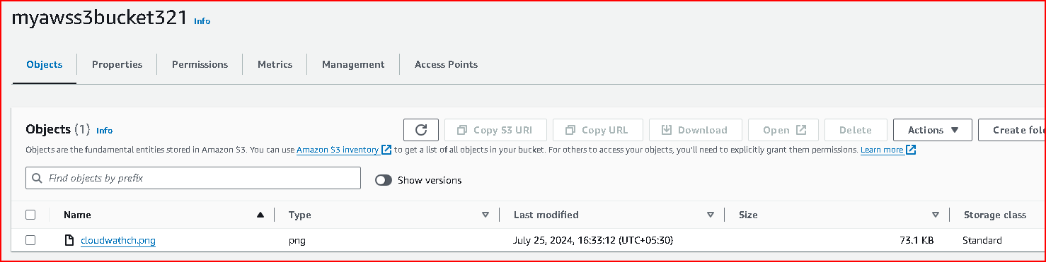

Object is reflected in destination bucket

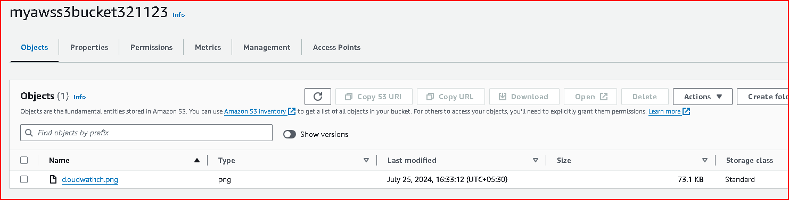

Step 4: Apply Lifecycle Policies

Lifecycle policies will transition objects to Glacier storage class after 30 days and delete them after 365 days.

Create Lifecycle Policy:

Select your primary bucket.

Go to the Management tab.

Click on Lifecycle and then + Add lifecycle rule.

Configure the rule:

Name: Give your rule a name.

Scope: Apply the rule to all objects or filter by prefix/tag.

Transitions: Add a transition to Glacier after 30 days.

Expiration: Permanently delete objects after 365 days

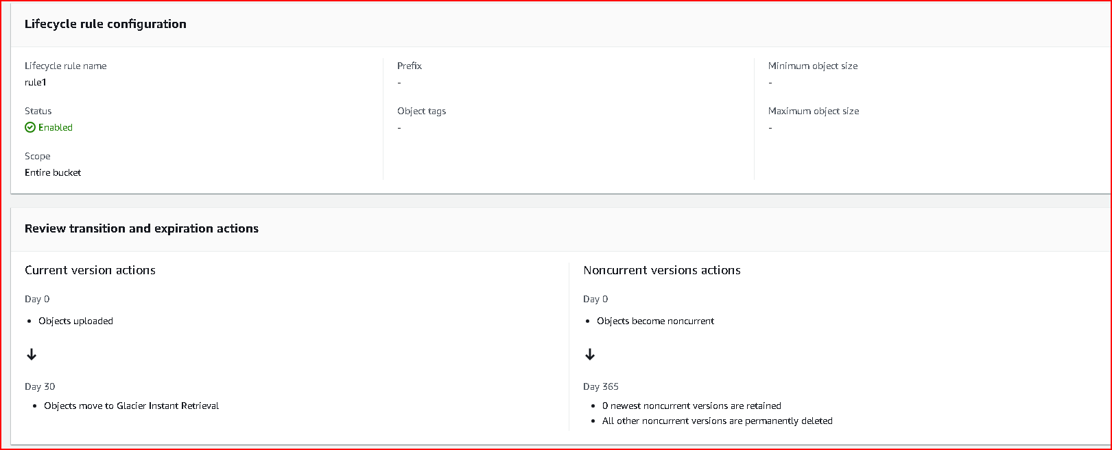

Step 5: Enable Server-Side Encryption

Enable server-side encryption to ensure that objects stored in S3 are encrypted at rest.

Enable Encryption:

Select your primary bucket.

Go to the Properties tab.

Click on Default encryption.

Choose the encryption option.

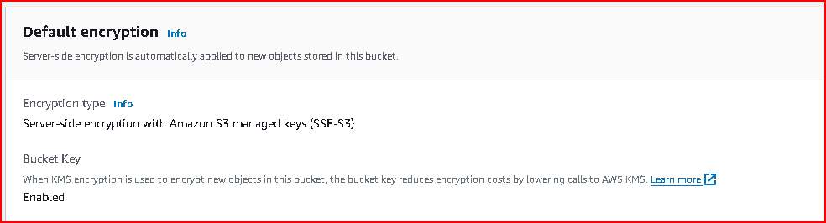

Ensure that you also enable encryption on the replica bucket.

Step 6: Set Up Static Website Hosting

You can configure your bucket to host a static website.

Configure Static Website Hosting:

Select your primary bucket.

Go to the Properties tab.

Click on Static website hosting.

Choose Use this bucket to host a website.

Specify the index document and error document if needed.

Save the configuration.

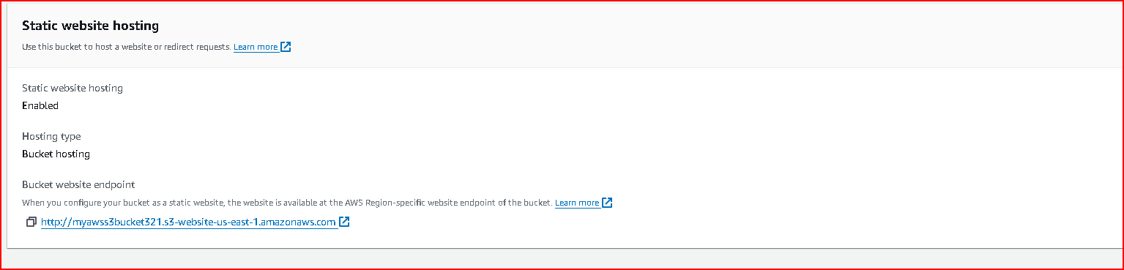

Upload the index.html file and check if it is working.

